People Analytics

Project Report

at the Faculty of Business, Economics, and Law

Friedrich-Alexander-Universität Erlangen-Nürnberg

Schöller Endowed Chair for Information Systems

Prof. Dr. Sven Laumer

Presented by: Ibne Sayad

Am Europakanal 36

Erlangen

+49 163 6976593  
ibne.sayad@fau.de

23365652

Final Date of Submission: 2024-07-31

# Content

Content 2

1 Well-Being 4

1.1 The importance of well-being *(4 Points)* 4

1.2 Stress induced by technology *(7 Points)* 4

1.3 Employee well-being dataset *(8 Points)* 4

1.4 Predictive well-being algorithm *(6 Points)* 5

2 Turnover 6

2.1 Employee Turnover *(4 Points)* 6

2.2 Employee Turnover Theories *(6 Points)* 6

2.3 Employee Turnover Dataset *(10 Points)* 7

2.4 Turnover prediction *(5 Points)* 7

References VII

Declaration of Academic Integrity at the Schöller Endowed Chair for Information Systems VIII

# Well-Being

## The importance of well-being *(4 Points)*

Monitoring employee well-being is crucial for organizations like FAU Bank for several reasons. Primarily, well-being significantly influences employee performance and productivity. Employees who feel valued and healthy are more likely to be engaged, motivated, and productive, directly benefiting the company's overall performance. Additionally, a focus on well-being can reduce turnover rates and absenteeism, as employees are less likely to leave an organization that prioritizes their health and satisfaction. Moreover, neglecting well-being can lead to increased healthcare costs, as employees under stress or experiencing burnout may require more medical attention.

Several factors can lead to low levels of employee well-being and an unhealthy work-life balance:

**Work Environment Stressors:** This includes long working hours, excessive workload, and high-pressure environments. Such conditions can lead to burnout and decreased job satisfaction.

**Technostress:** The pressure from constant connectivity and the need to adapt to new technologies can cause stress. Technostress is particularly concerning as it can blur the lines between work and personal life, leading to an unhealthy work-life balance.

**Lack of Social Support:** Employees who lack a supportive network at work may experience lower well-being. This includes poor relationships with supervisors or colleagues, which can lead to feelings of isolation.

**Job Insecurity:** Concerns about job stability, such as potential layoffs or the fear of being replaced by technology, can cause significant stress and anxiety among employees.

**Conflicts Between Work and Family Life:** Difficulties in balancing work responsibilities with personal life can lead to stress and negatively affect overall well-being. This is particularly relevant when work demands interfere with family time or personal relaxation.

To effectively monitor and improve employee well-being, FAU Bank can adopt several practical approaches:

**Surveys and Feedback Mechanisms:** Regularly conducting anonymous surveys can help gauge employee satisfaction and identify stressors. This data can be used to tailor interventions and support programs.

**Well-Being Programs:** Implementing programs that promote physical health, mental well-being, and financial stability can help. This includes offering gym memberships, mental health days, financial planning workshops, and stress management seminars.

**Flexible Work Arrangements:** Providing flexible working hours or remote work options can help employees better manage their work-life balance, reducing stress and increasing job satisfaction.

**Supportive Management Practices:** Training managers to recognize signs of burnout and stress can enable them to support their teams more effectively. This includes fostering an inclusive work environment where employees feel safe and valued.

**Monitoring and Analytics:** Utilizing data analytics to track well-being indicators can provide insights into the overall health of the workforce. This data can highlight trends and areas needing improvement, allowing for proactive management interventions.

By focusing on these strategies, FAU Bank can foster a healthier, more productive work environment, ultimately benefiting both employees and the organization as a whole.

## Stress induced by technology *(7 Points)*

Introducing a new Transaction Processing System (TPS) at FAU Bank, replacing the existing legacy system, could potentially lead to a variety of challenges and impacts, particularly on employee stress levels. Change management literature and studies on workplace stress suggest that such transitions can be fraught with both technical and human resource challenges.

Potential Challenges and Stressors

Learning Curve and Training: Employees accustomed to the legacy system may find the new TPS difficult to learn, leading to frustration and decreased productivity during the initial phases. The steep learning curve can contribute to anxiety and stress, especially among those less comfortable with technological changes.

Technological Anxiety: Technological changes can induce stress among employees, particularly if they feel unprepared or inadequately trained. This stress can be exacerbated if the new system is perceived as more complex or less intuitive than the legacy system.

Increased Workload: During the transition period, employees might experience an increased workload as they navigate both the old and new systems. This dual-system phase can lead to longer working hours, heightened stress, and potential burnout.

Job Security Concerns: Employees might worry about job security if the new TPS is seen as potentially automating tasks that were previously manual, leading to fears of redundancy.

Consequences

The consequences of heightened stress levels among employees due to the introduction of a new TPS can be significant. Increased stress can lead to reduced job satisfaction, lower productivity, and higher absenteeism. Furthermore, chronic stress is linked to health problems, which can increase healthcare costs and affect overall employee well-being. In extreme cases, this stress can lead to higher turnover rates, particularly if employees feel that their concerns are not being addressed.

Coping Strategies and Recommendations

Comprehensive Training: To mitigate these stressors, FAU Bank should invest in comprehensive training programs that are accessible and tailored to different learning styles. This training should not only cover the technical aspects of the new TPS but also include stress management techniques.

Effective Communication: Clear, consistent, and transparent communication is crucial. Employees should be informed about the reasons for the change, the benefits of the new system, and how it will impact their roles. Regular updates and an open channel for feedback can help alleviate anxiety.

Support Systems: Establishing support systems, such as help desks and peer support networks, can provide employees with resources to address issues as they arise. This can include technical support as well as counseling services for those struggling with the transition.

Gradual Implementation: A phased or gradual implementation of the new system can help employees adapt more comfortably. This allows for adjustments based on feedback and reduces the pressure of a sudden, large-scale change.

Engagement and Inclusion: Involving employees in the planning and implementation stages can foster a sense of ownership and reduce resistance. When employees feel their input is valued, they are more likely to support the change.

Conclusion

Transitioning to a new TPS at FAU Bank presents both opportunities and challenges. By acknowledging the potential for increased stress and proactively addressing it through training, communication, support, and inclusive practices, the bank can facilitate a smoother transition, minimizing negative impacts on employee well-being and maintaining operational efficiency.

## Employee well-being dataset *(8 Points)*

The dataset **“FAU_Bank_Employee_Wellbeing.csv”** has been considered for this task. Through data preprocessing, visualization, and correlation analysis, we aim to understand the main determinants of work-life balance and how different demographics and job roles experience work-related stress and leisure time differently.

**Checking Missing Values:** The code checks for missing values using the specific function “**wellbeing_data.isnull().sum()**”. It's crucial to assess missing data to determine if imputation or removal is necessary.

**Feature Selection:** The column “**Employee_ID**” has been dropped from the table. This decision is justified because “**Employee_ID**” typically serves as an identifier and does not contain information that would contribute to the analysis of work-life balance or other factors.

**Mapping Categorical to Numeric Values:**

**Age:** Converted from string categories to numeric values using a mapping dictionary. This conversion facilitates numerical analysis and correlations.

**Gender:** Similarly, gender was mapped to numeric values (‘0’ for Male and ‘1’ for Female), making it easier to analyze and visualize.

**Data Visualization: Daily Stress by Gender**

The bar chart illustrates daily stress levels by gender. It shows that females are slidely more stassed.

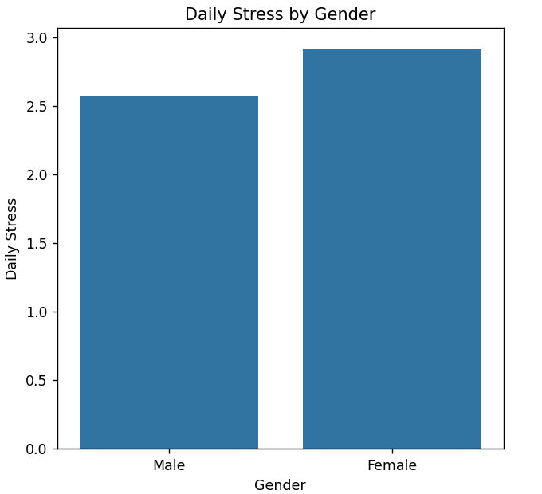

Figure 01: Daily Stress by Gender

**Daily Stress by Job Role:** The bar chart visualizes daily stress by job role. It shows that job role like Human resources & Loan processors faces more stress than others.

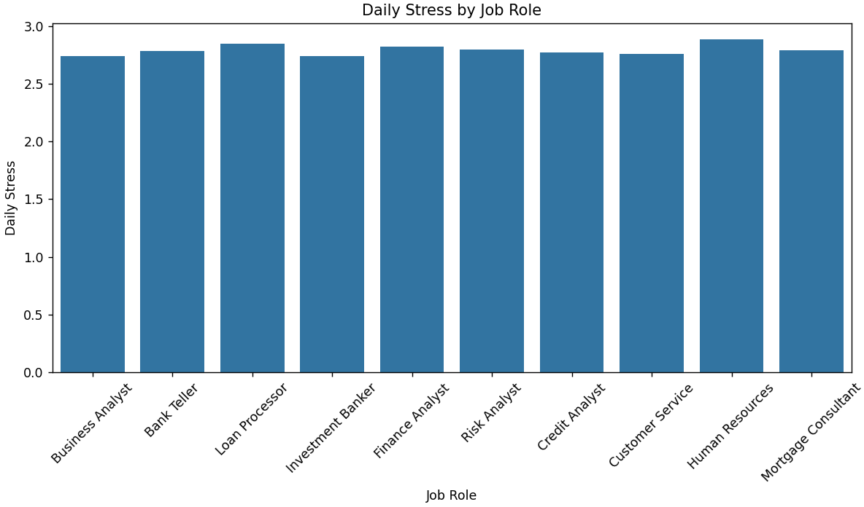

Figure 02: Daily Stress by Job Role

**Average Time Dedicated to Hobbies by Gender:** The bar chart represents who dedicates more time to hobbies, men or women. It shows that male spends a little more time on their hobbies.

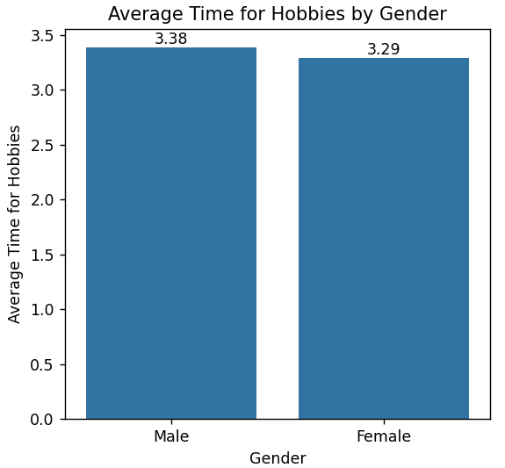

Figure 03: Avg. time dedicated to hobbies by Gender

**Correlation Heatmap:** The correlation heatmap helps identify the variables most related to the “WORK_LIFE_BALANCE_SCORE’’.

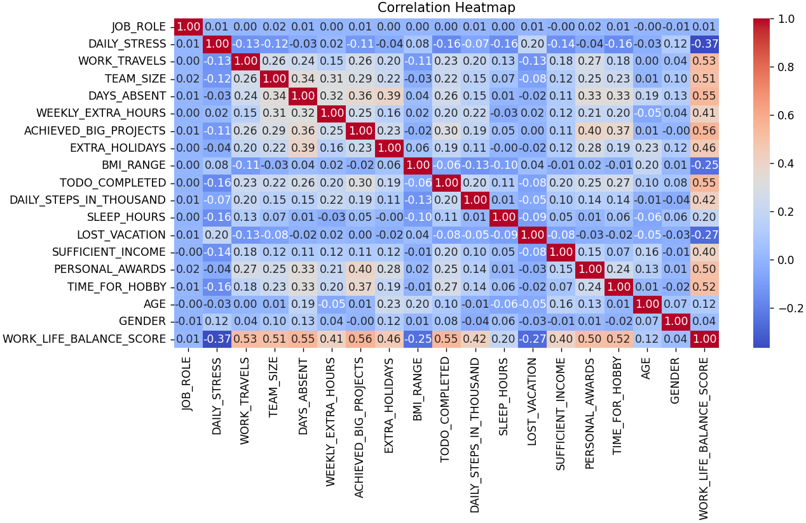

Figure 04: Correlation Heatmap

**Most Correlated Factors:** The heat map clearly shows the correlated attributes related to WLB. The list completed list has also been printed in the console. Where it shows that the most **positively** correlated values. These are the top 5 : ACHIEVED_BIG_PROJECTS: 0.56, DAYS_ABSENT: 0.55, TODO_COMPLETED: 0.56, WORK_TRAVELS: 0.53, TIME_FOR_HOBBY: 0.52.

On the other hand, the **negatively** correlated values are: GENDER: 0.04, JOB_ROLE: 0.01, BMI_RANGE: -0.25, LOST_VACATION: -0.27, DAILY_STRESS: -0.36

## Predictive well-being algorithm *(6 Points)*

The goal is to build and train a predictive model using the provided dataset to forecast the “WORK_LIFE_BALANCE_SCORE” (WLB) for employees. Here are the steps taken:

**Data Preprocessing:** Categorical data (age, gender, job role) was mapped to numerical values to facilitate analysis. Missing values in the dataset were imputed using the mean strategy to maintain numerical stability.

Model Training: A Linear Regression model was trained using the dataset, with the “WORK_LIFE_BALANCE_SCORE” as the target variable.

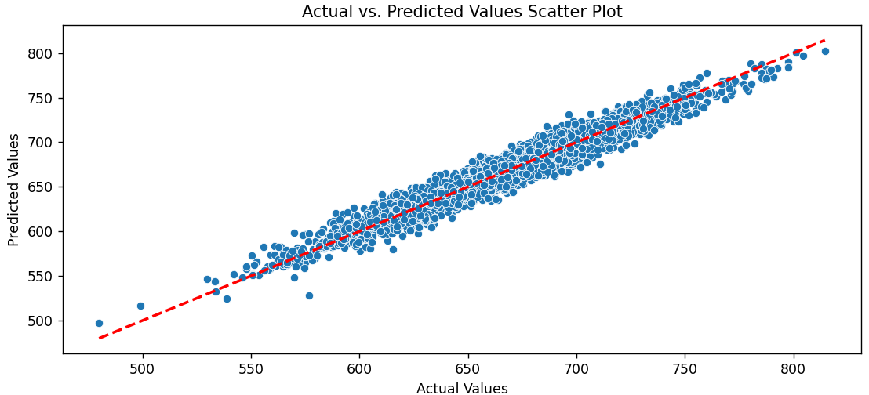

Figure 05: Scatter plot of the predicted values

Evaluation: The model's performance was evaluated using the R² score, which indicates the proportion of variance in the dependent variable that is predictable from the independent variables.

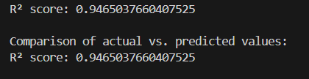

**Comparison of Actual vs. Predicted Values:**

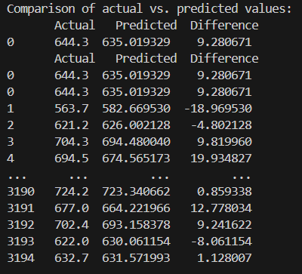

Predicting the WLB Score for a Hypothetical New Employee:



Suggested Steps for FAU Bank: Based on the findings from the predictive model and data analysis, the following steps are recommended to improve employees' work-life balance:

Stress Management Programs: Implement stress reduction initiatives, especially targeting roles identified with higher stress levels.

Flexible Work Options: Introduce or expand flexible work schedules and remote work opportunities, particularly for employees in job roles with lower WLB scores.

Health and Wellness Programs: Promote health and wellness programs, including mental health support, fitness activities, and hobby clubs, to encourage employees to engage in activities outside of work.

Recognition and Reward Systems: Enhance recognition and reward systems to acknowledge employees' achievements, which can improve job satisfaction and work-life balance.

Financial Counseling: Provide financial planning and counseling services to assist employees in managing their finances, especially for those reporting insufficient income.

Implementing these measures can help create a more supportive and balanced work environment, contributing to overall employee satisfaction and productivity.

# Turnover

Voluntary employee turnover refers to the process wherein employees choose to leave an organization of their own accord. This type of turnover is distinct from involuntary turnover, where the employer initiates the separation due to factors such as layoffs or dismissals. Voluntary turnover is a critical metric for organizations because it can indicate dissatisfaction among employees, or that competitors are offering more attractive opportunities. The implications of high voluntary turnover are multifaceted and generally adverse for organizations. First and foremost, there is the direct financial cost associated with recruiting, hiring, and training new employees, which can range from 30% to 400% of the departing employee's annual salary. Additionally, turnover can lead to a loss of institutional knowledge, disruptions in service or production, and decreased morale among remaining employees, potentially leading to further turnover.

**Causes of Voluntary Employee Turnover:** The reasons behind why employees leave are complex and can be influenced by numerous factors. According to the Organization Equilibrium Theory proposed by March and Simon (1958), turnover occurs when the perceived value of an employee's contributions exceeds the incentives offered by the organization. This mismatch can be due to inadequate compensation, lack of career advancement opportunities, or unsatisfactory working conditions.

**Addressing Voluntary Turnover:** For organizations like FAU Bank, which face significant voluntary turnover, it is crucial to understand these underlying causes to develop effective retention strategies. Data-driven approaches can be instrumental in predicting turnover and identifying at-risk employees. By analyzing patterns in turnover data, organizations can pinpoint specific departments or demographic groups that are more prone to leaving and investigate the underlying reasons, whether they be job dissatisfaction, lack of advancement, or external market factors.

Implementing comprehensive retention plans that address identified issues can significantly reduce turnover rates. Such plans might include revising compensation structures, enhancing career development programs, improving workplace culture, and ensuring better alignment between employees' roles and their personal and professional aspirations. Additionally, maintaining a strong organizational culture that fosters a sense of belonging and engagement can be a powerful deterrent to turnover.

In summary, voluntary employee turnover is a critical concern for organizations due to its financial and operational impacts. Understanding and addressing the causes of turnover through data-driven strategies and targeted interventions can help organizations retain valuable talent and maintain a stable workforce.

## Employee Turnover Theories *(6 Points)*

**Case 1: Jane's Situation**

**Turnover Theory: Job Embeddedness**

The case of Jane, a bank teller at FAU Bank, can be best understood through the lens of the **Job Embeddedness Theory**. This theory suggests that employees are more likely to stay in their jobs when they feel a strong sense of "fit" and "links" to their organization and community. "Fit" refers to how well an employee's values, career goals, and plans for the future align with those of the organization. "Links" are the formal or informal connections that bind employees to their organization and community, including relationships with colleagues and social ties outside of work.

In Jane's situation, while she aligns with the bank's priority on personalized customer service, her lack of meaningful social connections and relationships within the workplace signifies a weak "link" component. This sense of disconnection can significantly influence her intention to leave, despite any alignment with organizational goals or values.

**Retention Strategies for Jane:** FAU Bank should focus on strengthening workplace relationships and fostering a supportive community to retain employees like Jane. This can be achieved through:

**Team-Building Activities:** Regular team-building exercises can help employees connect on a personal level, improving camaraderie and mutual support.

**Mentorship Programs:** Establishing mentorship or buddy systems for new employees can facilitate integration and provide ongoing support, helping to build stronger interpersonal connections.

**Encouraging Social Interactions:** Creating spaces and opportunities for informal social interactions, such as social events or casual get-togethers, can help employees bond and feel more connected to their colleagues.

**Employee Resource Groups**: Supporting the formation of employee resource groups based on shared interests or demographics can provide additional support networks and a sense of belonging.

**Case 2: John's Situation: Turnover Theory**

**Unfolding Model of Turnover**

John's case can be best explained using the Unfolding Model of Turnover. This theory posits that employees' decisions to leave are often triggered by specific "shocks" or events that cause them to re-evaluate their relationship with their employer. These shocks can be personal, such as changes in family circumstances, or organizational, such as shifts in company policy or structure.

In John's case, the acquisition of his innovative software company by FAU Bank represented a significant shock. His distress and subsequent decision to leave were triggered by the perceived loss of autonomy and a shift towards a more hierarchical corporate structure, which conflicted with his values of independence and flexibility.

Retention Strategies for Situations Like John's: For employees like John, who value autonomy and a flat organizational structure, FAU Bank could implement strategies to mitigate the impacts of such organizational changes:

Clear Communication and Involvement: During significant organizational changes, clear communication about the reasons for changes and how they will be managed is crucial. Involving employees in decision-making processes where possible can help them feel valued and maintain a sense of control over their work environment.

Maintaining Autonomy: Even within a larger corporate structure, efforts can be made to preserve elements of autonomy and innovative culture. This could include allowing flexible working arrangements, supporting independent projects, and fostering a culture of innovation.

Transition Support: Providing support during transitions, such as counseling services, career coaching, and workshops on adapting to change, can help employees navigate new organizational landscapes and reduce turnover due to shock.

Conclusion

In both cases, understanding the underlying psychological and social factors that influence turnover decisions is critical for effective management and retention strategies. By addressing these specific needs and concerns, FAU Bank can create a more supportive and engaging work environment, reducing turnover and fostering long-term employee loyalty.

## Employee Turnover Dataset *(10 Points)*

The "**FAU_Bank_turnover.csv**" dataset provides information on various factors related to employee turnover at FAU Bank, including job roles, salary levels, job satisfaction, and tenure. The primary focus is on understanding the attributes that contribute to employees leaving the company, indicated by the "left" column (1 for those who left, 0 for those still employed).

**Average Job Satisfaction Level of Employees Who Left:** The average job satisfaction level among employees who left the company was calculated. This metric provides insight into whether dissatisfaction in the workplace contributed to their departure.

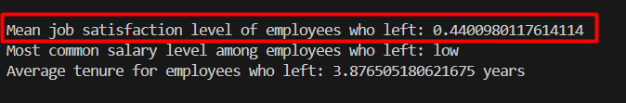

**Average Salary Satisfaction Level of Employees Who Left:** The most common salary level among employees who left was identified. This helps to understand if salary was a significant factor in turnover, especially if a particular salary band has a higher departure rate.

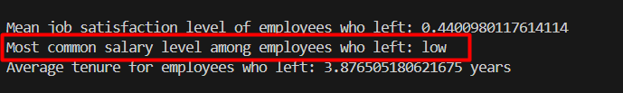

**Average Tenure of Employees Who Left:** The average duration (tenure) that employees stayed with the company before leaving was calculated. This information is crucial for understanding the typical employee lifecycle and potential turnover timing.

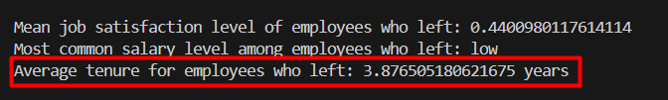

**Impact of Salary on Turnover**: Turnover rates were analyzed by salary level to assess if compensation influences the decision to leave the company. A higher turnover rate in lower salary bands could indicate dissatisfaction with compensation.

.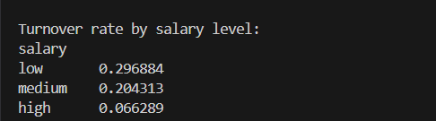

**Correlation Analysis with 'Left' Column:** A correlation matrix was created to identify attributes most strongly associated with the likelihood of an employee leaving the company. Key correlations can reveal significant factors contributing to turnover, such as job satisfaction, work intensity, or performance evaluations. The findings from the correlation matrix help prioritize areas for intervention. For example, a strong negative correlation between job satisfaction and leaving indicates that improving job satisfaction could reduce turnover.

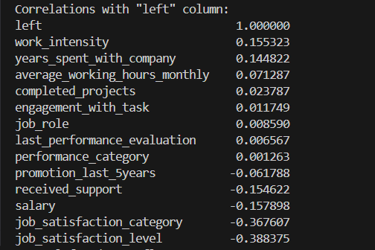

Visualizing the Correlation Matrix: A heatmap is generated for better visualization.

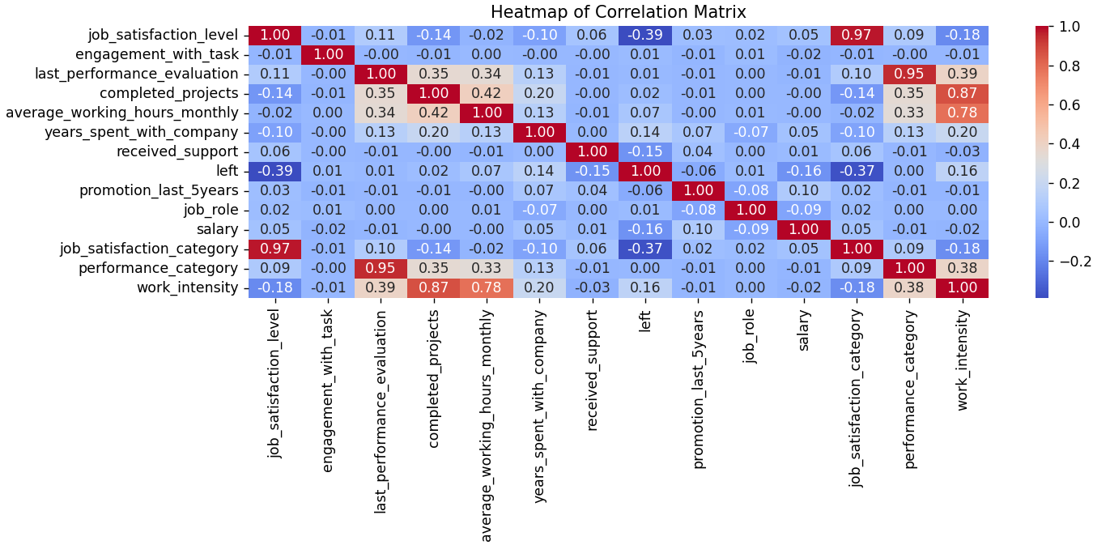

**Data Preprocessing Steps that considered:**

Convert Job Roles to Numeric Data Type: Facilitate quantitative analysis by encoding categorical job roles into numeric form. A mapping dictionary was created to convert job roles from strings to integers. For example, 'bank_teller' was mapped to 1, 'business_analyst' to 2, and so on.

Convert Salary from Categorical to Numeric Data Type: Standardize salary levels to numerical values for consistency in analysis. Salary categories ('low', 'medium', 'high') were mapped to integers 1, 2, and 3, respectively.

Data Binning for Continuous Variables: Simplify continuous data (job satisfaction and performance evaluation) into categorical bins to reduce variability and highlight patterns. Both job satisfaction and last performance evaluation were divided into 5 bins, each representing a range of values.

Create a New Feature for Work Intensity: Combine related variables (number of projects and average working hours) into a single feature, reflecting overall work intensity. A new column "work_intensity" was calculated by multiplying the number of completed projects by the average monthly working hours.

These preprocessing steps transformed the data into a more analysis-friendly format, facilitating the identification of key factors influencing employee turnover. The process ensured that all data was in a numeric format, binned appropriately, and incorporated new features that better represented employee experiences.

## Turnover prediction *(5 Points)*

For predicting employee turnover, a **Gradient Boosting Classifier** was chosen due to its robustness in handling various types of data and ability to capture complex relationships between features. This algorithm is particularly effective in dealing with non-linear data and is known for providing good accuracy and interpretability through feature importance scores.

Performance Evaluation

Accuracy: The model's accuracy is a basic metric showing the proportion of correctly predicted instances. However, it's essential to consider other metrics for imbalanced datasets (like turnover prediction). The accuracy of the model came **97%** for this model.



Confusion Matrix: This matrix provides insight into the types of errors the model makes, showing the counts of true positives, true negatives, false positives, and false negatives. It helps in understanding the model's performance on each class.

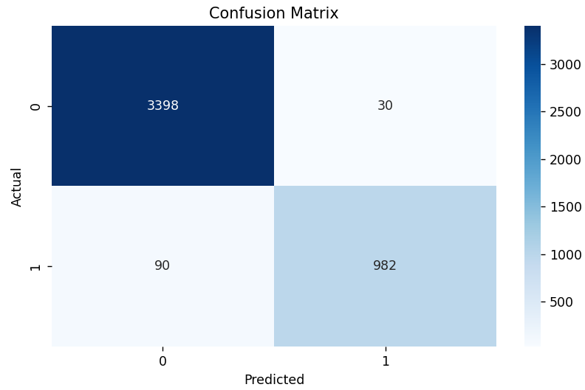

Classification Report: Includes precision, recall, and F1-score for each class, offering a more detailed view of the model’s performance, especially on how well it distinguishes between employees who will leave and those who will stay.

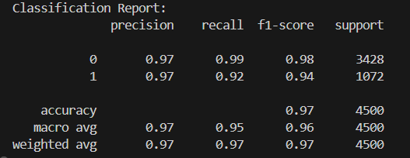

**Key Predictive Factors:** From the feature importance analysis, factors like job satisfaction level, last performance evaluation, and engagement with tasks were significant predictors of turnover. This indicates that employees with lower satisfaction and engagement levels are more likely to leave.

**Confusion Matrix Insights:** The confusion matrix revealed that the model can distinguish fairly well between those who will leave and those who will stay, but there may be some instances of misclassification that need further investigation.

**Recommendations for FAU Bank**

Improve Job Satisfaction: Since job satisfaction is a strong predictor of turnover, the bank should focus on initiatives to improve workplace satisfaction, such as regular feedback, career development opportunities, and a positive work environment.

Enhance Performance Evaluation Processes: Regular and constructive performance evaluations can help identify and address issues early, potentially reducing turnover.

Employee Engagement Programs: Increasing employee engagement through recognition programs, team-building activities, and clear communication can help in retaining employees.

Tailored Retention Strategies: Analyzing the data further to understand specific issues for different job roles or salary levels could lead to more targeted retention strategies. For instance, if lower salary levels are linked to higher turnover, reviewing compensation packages might be necessary.

The Gradient Boosting model provides a good balance between predictive accuracy and interpretability. By understanding the significant factors contributing to turnover, FAU Bank can implement targeted interventions to retain talent and reduce turnover costs.

# References

Mitchell, T. R., Holtom, B. C., Lee, T. W., Sablynski, C. J., & Erez, M. (2001). Why people stay: Using job embeddedness to predict voluntary turnover. Academy of Management Journal, 44(6), 1102-1121.

Lee, T. W., & Mitchell, T. R. (1994). An alternative approach: The unfolding model of voluntary employee turnover. Academy of Management Review, 19(1), 51-89.

Allen, D. G., Bryant, P. C., & Vardaman, J. M. (2010). Retaining talent: Replacing misconceptions with evidence-based strategies. Academy of Management Perspectives, 24(2), 48-64.

Meyer, J. P., & Allen, N. J. (1991). A three-component conceptualization of organizational commitment. Human Resource Management Review, 1(1), 61-89.

Rousseau, D. M. (1995). Psychological contracts in organizations: Understanding written and unwritten agreements. SAGE Publications.

Eisenberger, R., Huntington, R., Hutchison, S., & Sowa, D. (1986). Perceived organizational support. Journal of Applied Psychology, 71(3), 500-507.

# Declaration of Academic Integrity at the Schöller Endowed Chair for Information Systems

I hereby certify that I have prepared the submitted work independently, and without the unauthorized assistance of third parties, as well as without the use of unauthorized aids. The work has not been submitted in the same or similar form to any other examination authority, nor has it been accepted by any other examination authority as part of an examination.

The passages in the work, which have been taken from other sources in terms of wording or meaning, are identified by indicating the origin. This also applies to drawings, sketches, picture representations and sources from the Internet.

I am aware that the use of artificial intelligence is permitted for work at the Schöller Endowed Chair of Information Systems, Digitalization in Business and Society (esp. to improve the text written by myself). However, the intellectual core of the respective work has been developed by me, and the scientific methods that are part of the work have been carried out by myself. Furthermore, I have transparently communicated the aids used in the work.

Violations of the above-mentioned rules are to be qualified as deception or attempted deception and lead to an assessment of the examination with "failed". Further sanctions are possible in the case of multiple or particularly drastic violations of the rules by the examination board.

________Ibne Sayad___________

First name Middle names Surname Erlangen, 2024-07-31